Ordering Guide

Table of Contents
Table of Contents 2
Ordering Options 3
Base Macropad 3
Switches 3
Colored Hot Swap Sockets 3

Ordering Options
Option | Price ($CAD) | Lead Time
Base Macropad | 50 | 0-4 weeks*
Switches | 15 | 3 weeks**
Keycaps | 15 | 3 weeks**
Colored Hot Swap Sockets | 10 | 3 weeks**

*This depends heavily on if we currently have the basic parts of the NumM Pad in stock, and which parts we need to purchase to complete it.
**Choosing multiple options doesn’t increase the lead time beyond 3 weeks, however, there may be delays in shipping or customs, which may increase the lead time significantly

Base Macropad
The base macropad has 28 keys and 2 rotary encoders, comes with a case, stabilizer, encoder knobs, and includes a 3ft USB-A to C cable.

Switches
Choice of switches includes the following:
Switch | Actuation Type | Actuation Force (g)
Gateron Clear | Linear | 35
Gateron Red | Linear | 45
Gateron Yellow | Linear | 50
Gateron Black | Linear | 60
Gateron Brown | Tactile | 55
Gateron Blue | Clicky | 60
Gateron Green | Clicky | 80

Colored Hot Swap Sockets
Hot swap colors include the following:
White:
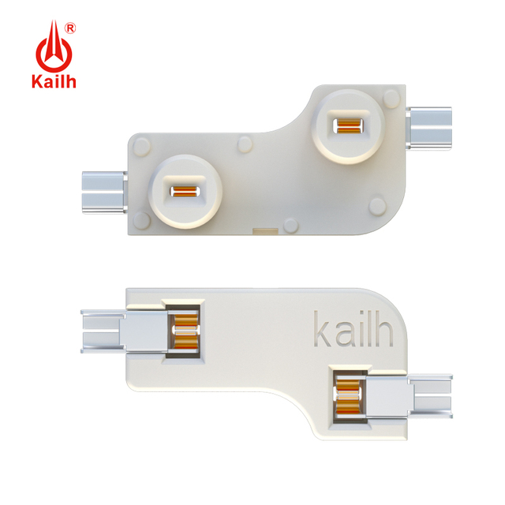
Jade Green:
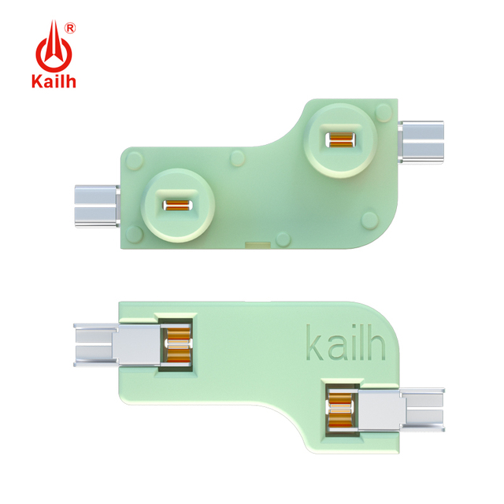
Blue:
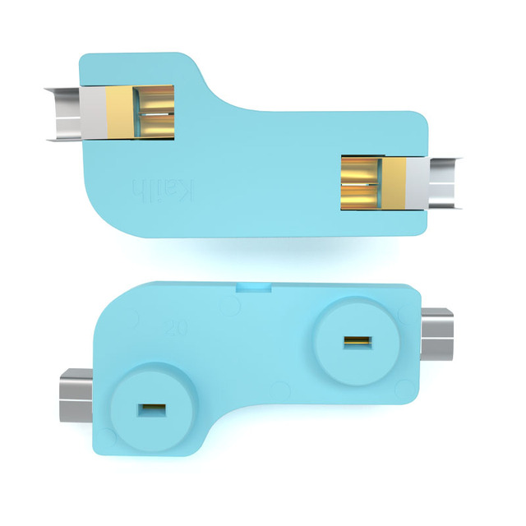
Pink:
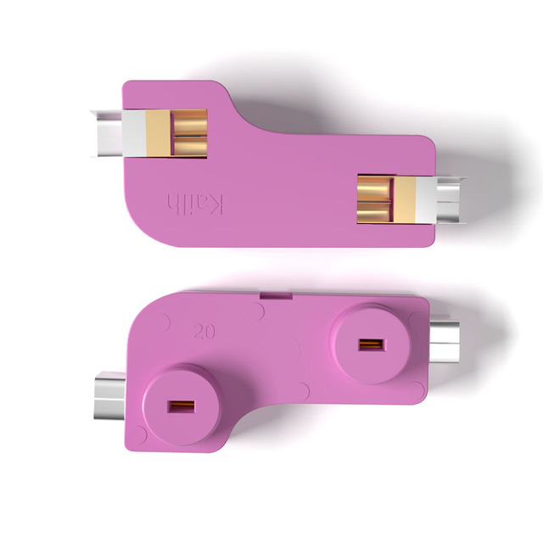
Purple:
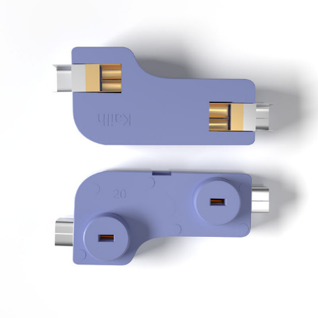
Black (standard):
